American Historical Biographies
Presentation of project: November 2,2017

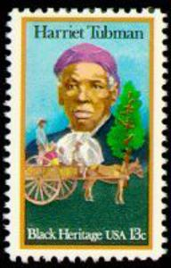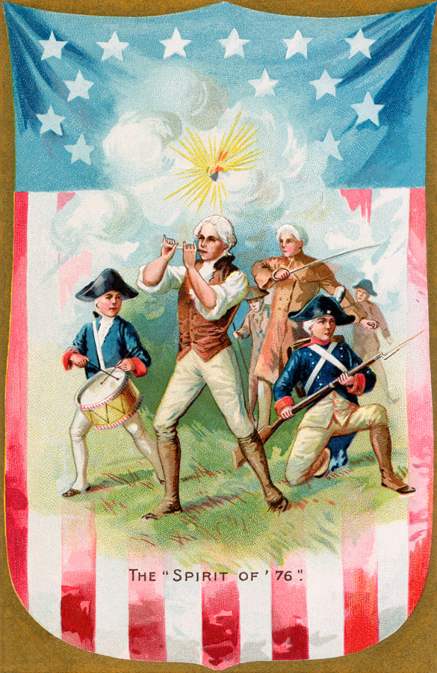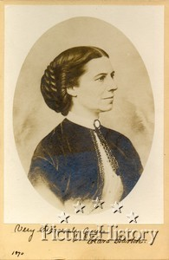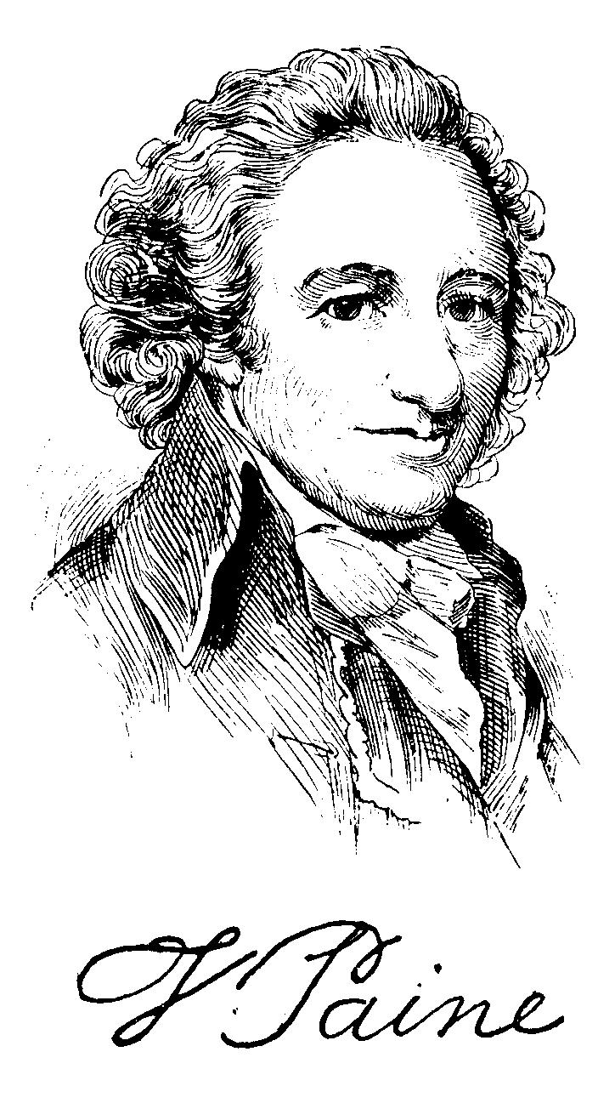

We encourage all 5th graders to complete this engaging project to kick off your study of American History. Students will be displaying and presenting their research in small groups at our first activity day on November 2, 2017.

Guidelines for the Project:
- Research a famous American historical figure using the outline provided. Refer to your 5th grade history text, Biographical Dictionary (pages R78-R85), for a list of possibilities. Let us know who you’ve chosen in order to eliminate duplicates. cbrodie@hickmanschools.org.

- Display your research using poster boards no smaller than 11” x 18” (see evaluation form). Poster boards are available in the annex. Please do not use tri-fold boards, as they are not able to be attached to the wall in the library.

- Create a three-minute oral presentation. Dressing as your historical figure would be a fun addition! Presentations will be in small groups during our activity rotations.

- Rough drafts may be submitted to your education coordinator for review if desired.

*All posters meeting the above guidelines will be eligible for display in the Hickman Library.

