Serendipity, Issue #2
Shapes & Faces

Artist: Picasso
Picasso was actually born in Spain but lived in France a long time ago. He is older than Georgia O’Keefe! His art is called abstract because it resembles something, but it also looks pretty unique. We included the paintings to use for Picasso because he was a very avant-garde artist, so not all of his paintings are appropriate. Using one painting per week, and looking at it daily to really learn the painting, look for triangles, squares, circles, rectangles, and hexagons in the painting.
What do you notice? What do you wonder? Write these ideas on a chart to refer to each day.

Math:
1.Parent work: cut out various sized triangles, circles, hexagons, squares, and rectangles from a variety of colored construction paper (you can trace around pattern blocks). Draw a large oval on the paper to help them get started seeing a face. Spend some time looking at your faces in a mirror.
Child work: Have your child glue these cutouts as well as other shapes that s/he draws herself/himself onto the large sheet of construction paper to create a face. Use either crayon or markers to color in the parts s/he has drawn. There is no wrong way to do this. Just have fun and experiment!

2. Play “Fill the Outlined Shape” using pattern blocks (see pages 5 and 6 of this packet). You can find pattern blocks either in your math manipulative kit or at the Annex. As you play make sure the shape that is being played is identified by name (triangle, square, etc.)

Science:
Go on a nature shape scavenger hunt. Take a nice hike (Big Trees, Pinecrest, Yosemite, Orange Blossom Park, Knights Ferry, etc.) and look for shapes in nature like triangles, squares, rectangles, circles, and hexagons. Make sure to draw and label your findings in a nature journal. Try making rubbings using crayons. You can pick up a Composition Book in the Annex to use as a journal.

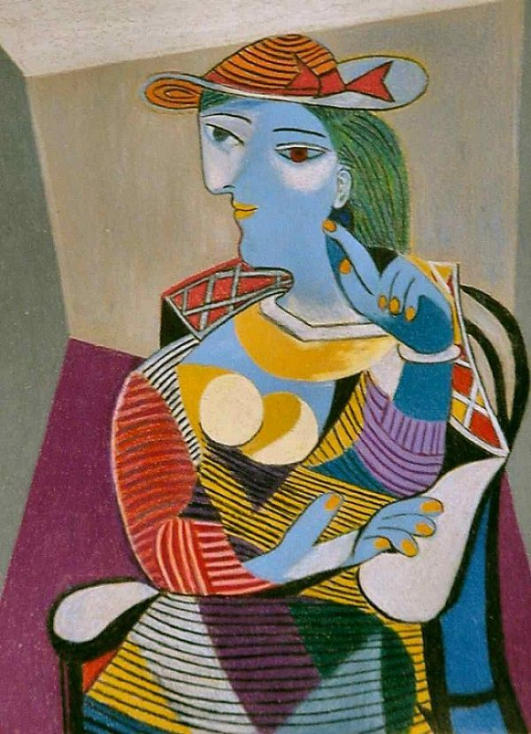

Seated Woman (Marie-Therese),1937 by Picasso
Courtesy of www.PabloPicasso.org

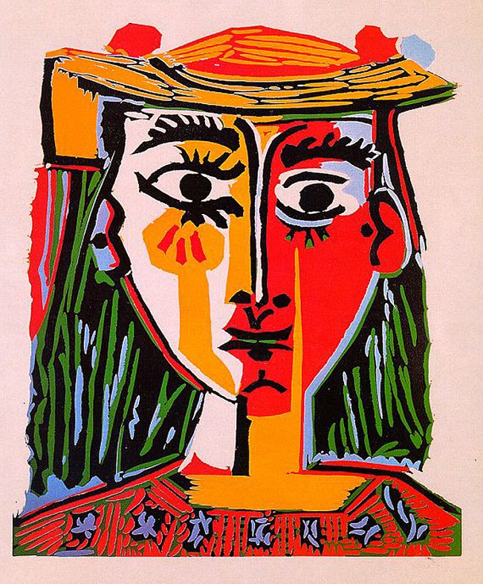

Head of a Woman in a Hat, 1962 by Pablo Picasso

pablopicasso.org

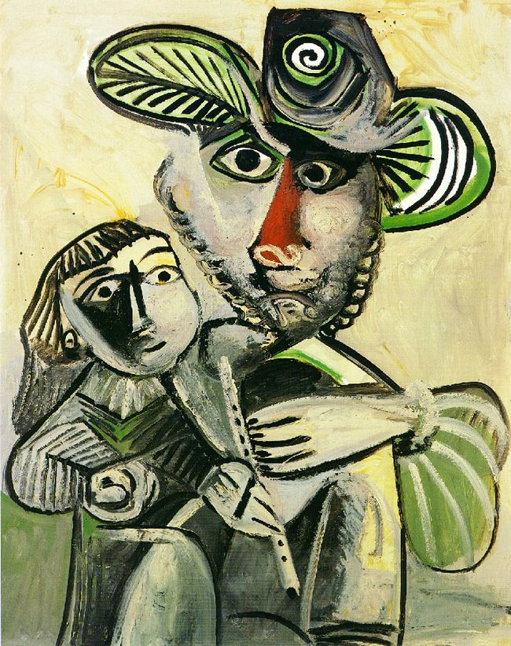

Fatherhood, 1971 by Picasso
pablopicasso.org
Fill the Outlined Shape

This experience is intended to create a sense of serendipity, discovery, about shapes and the development of math vocabulary. Use the following outlined shape on the next page and take turns filling it with various pattern blocks (found in your math manipulative kit or the Annex), always saying out loud the name of the shape being used (square-orange, triangle-green, rhombus-blue, hexagon-yellow, trapezoid-red). The goal is to fill in the whole outlined space perfectly. Once this is done, do it again trying to use other shapes in different places of the outline.

