Angel Island – Overnight Living History Program
October 24-25, 2018
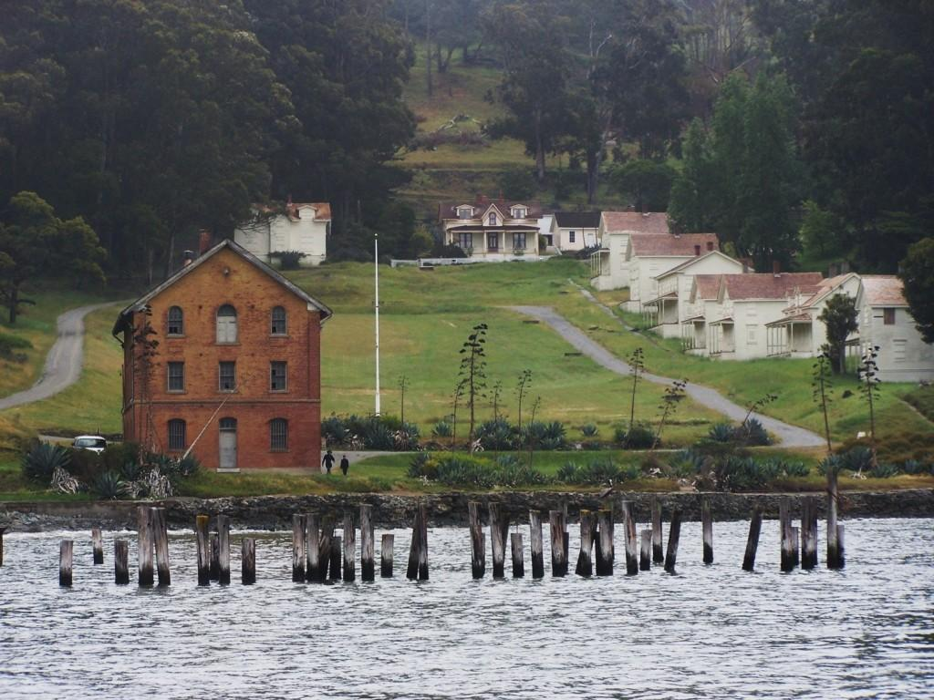

Camp Reynolds, Angel Island
The brick building in the photo is the Quartermaster building where your student will be staying overnight. Civil War activities and drills will take place in the various buildings and on the grassy area in the background.

The American History group has a unique opportunity once again this year to participate in an educational, fun and exciting living history overnight program held at Angel Island State Park in the San Francisco Bay area. Please read the following information with your student and fill out the necessary parent and student applications. There are only 33 students and 10 adult chaperone spots available for this trip
What is a Living History Program?
The Living History Program is a role-playing experience in which students participate in a simulated historic setting. Our program will be held on Angel Island at Camp Reynolds, a Union Civil War outpost. When the “new recruits” arrive on the island they will become Union Army soldiers from the year 1864. They will hike to Camp Reynolds carrying their personal gear and will be assigned bunks in the Quartermaster building. During the day, recruits will participate in training activities including militia drill, signaling, mess cooking, bread baking, and compass orienteering.
In the evening we will take a night hike up Mt. Livermore. One of the favorite activities for students is “Night Watch” in which each squad takes a turn keeping an eye on the camp to secure the location. In the morning, one squad will be chosen to assist in the cannon firing demonstration. Please take note that this trip will be a moderately strenuous activity, so be prepared for a workout.

Who can apply to go?
Students in the 5th grade (and the upperclassman who have not attended previously) will be given priority. Students must be in grades 5-8 to participate. Only complete applications that are entirely filled out (with the $40 payment attached) and received in the office by August 31 at 4:00 p.m. will be accepted into the lottery. Because the program limits us to 33 students and 10 adults, we have to have strict guidelines. Adult leaders are the sergeants. They will have specific responsibilities to man one of the afternoon rotation activities and to lead a squad.

What do I have to do?
Each recruit will be required to learn about the time period and about life at Camp Reynolds. (Material will be provided in advance.) A navy blue T-shirt is recommended. Hats will be provided. A mandatory organizational meeting for parents and students will be held on Wednesday, October 10, 2018 from 1:00-2:30 pm.

Is there a cost?
The cost will be $40.00 per participant (students as well as adult chaperones) to cover the cost of food, civil war cap, state park fees and the ferry ride to the island. Student and parent fees need to be received by the office no later than by August 31 at 4:00 p.m. Please submit a separate $40.00 check for each student/parent. Student vendor units may be used in place of a check for student fees only. If the student or parent chaperone was not chosen in the lottery, your payment will be returned to you as soon as possible. Parent drivers, please be prepared for an overnight parking charge in Tiburon (ranges from $5-$15). If your child is transported by another parent, you might want to consider making a contribution to help share with the gasoline and parking expense.

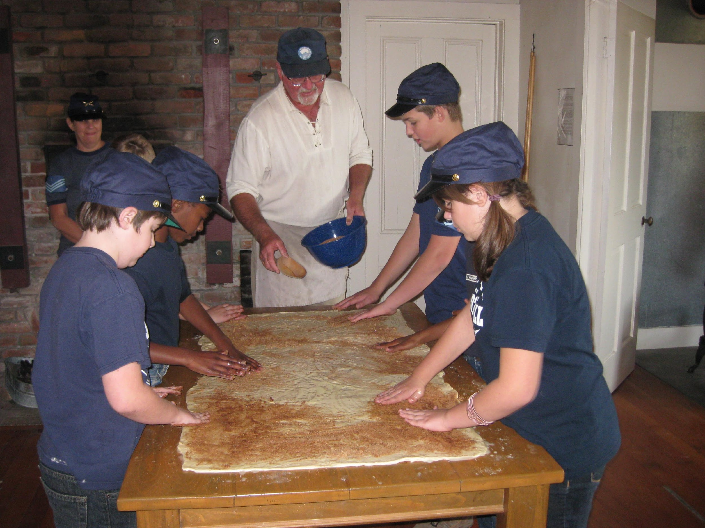
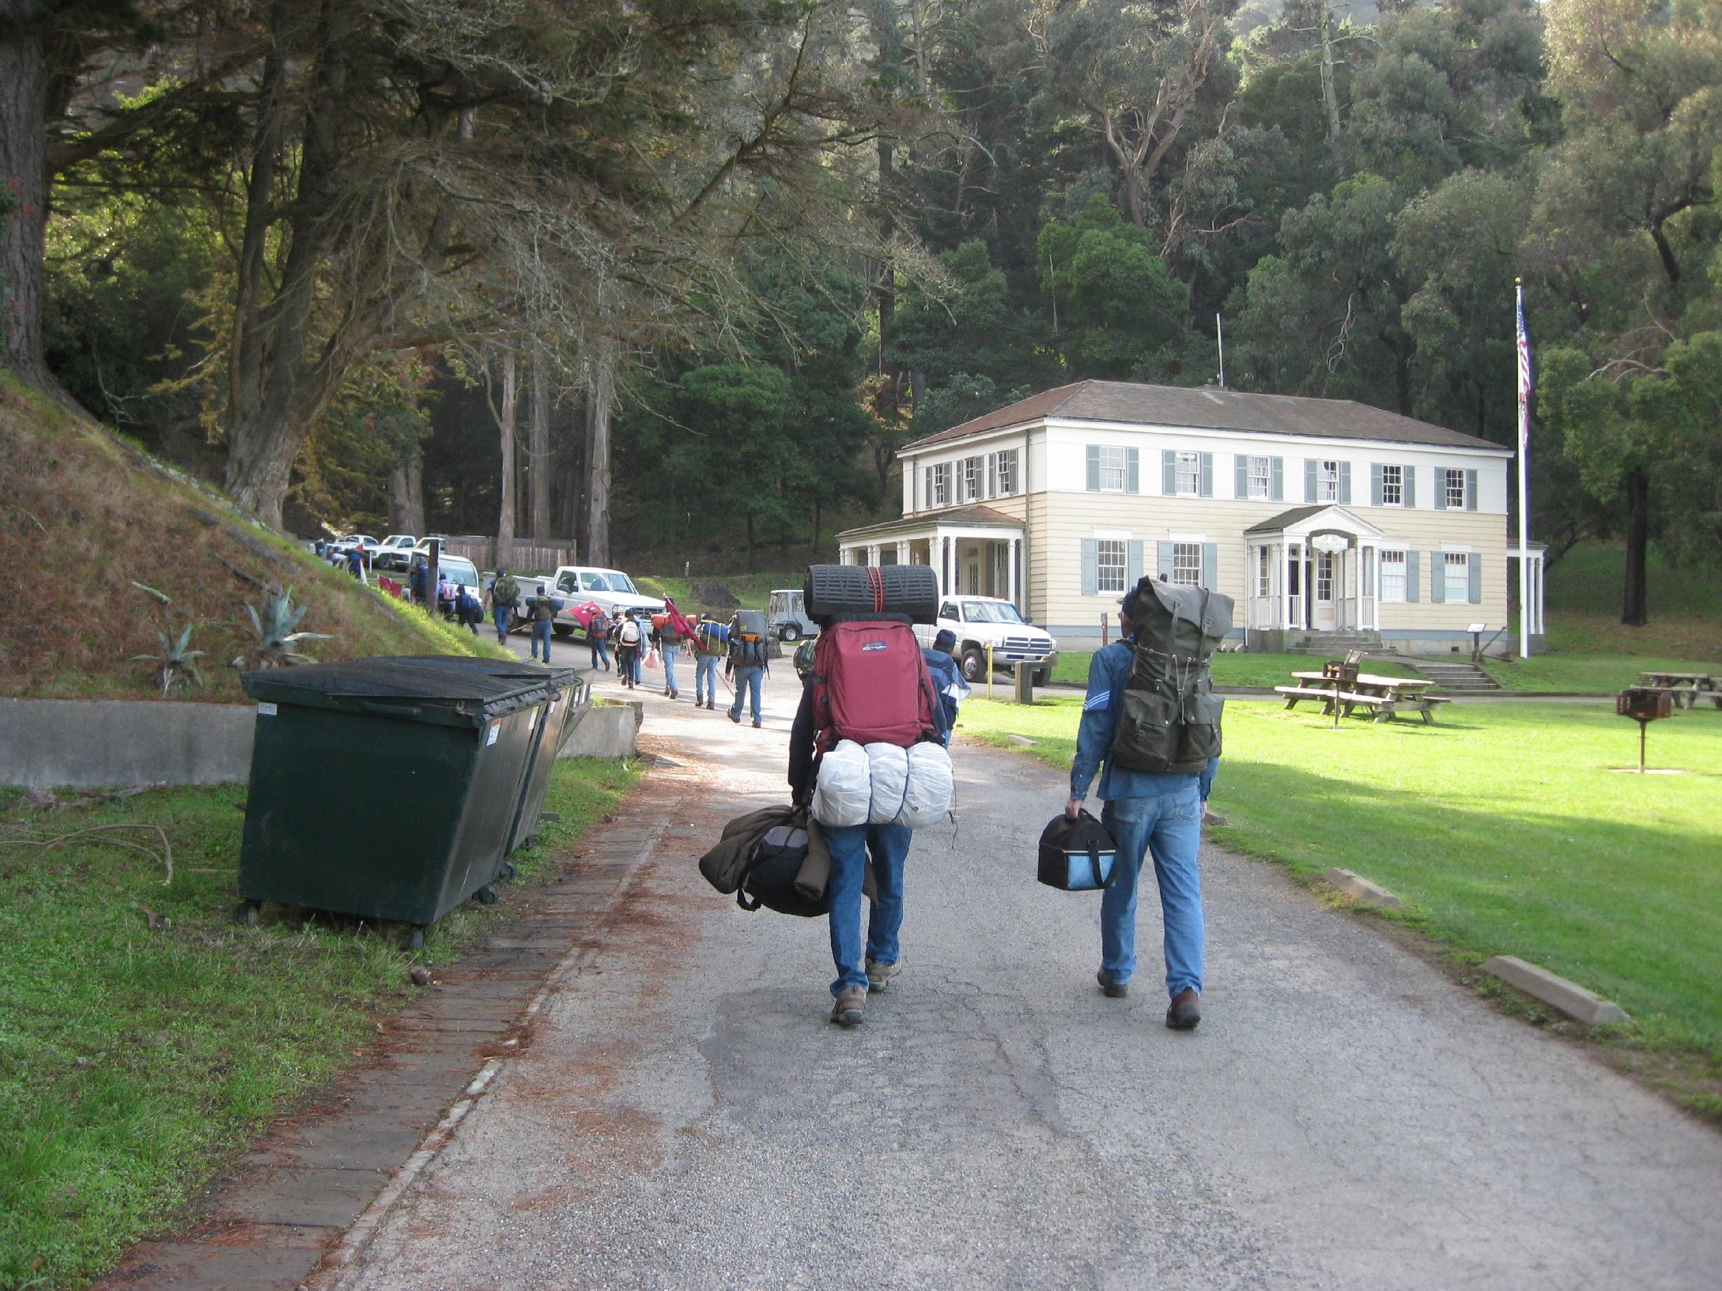
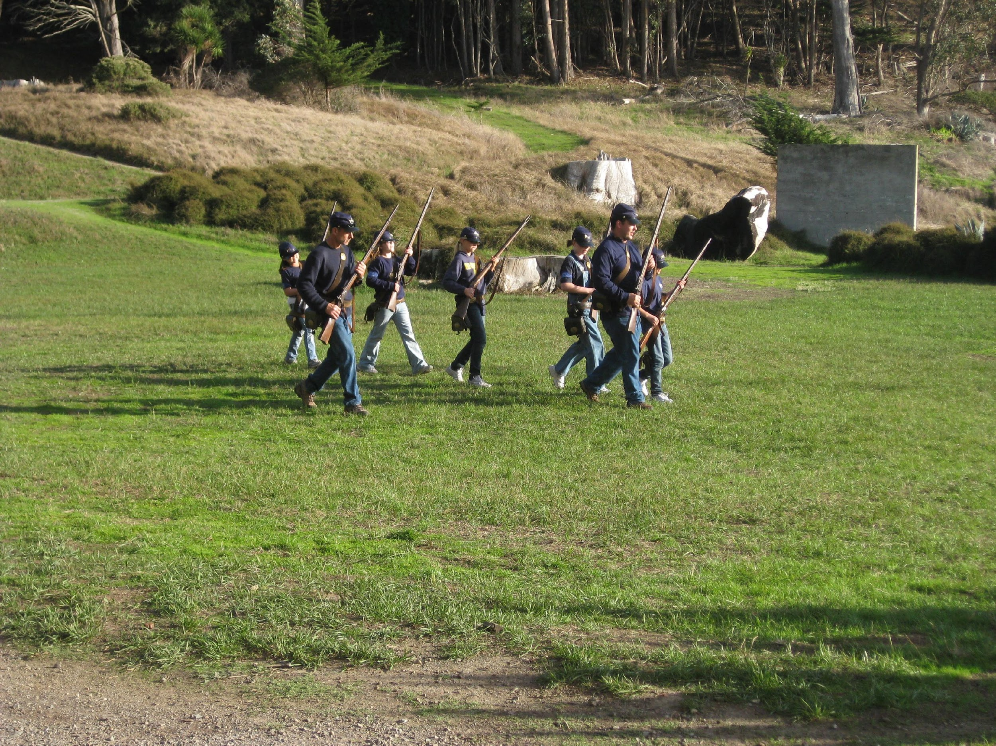
Pictures taken from previous trips to Angel Island

